# 

Extended Essay

Physical System Computer Modeling: Linear Motor System

# Is it possible to use a model-based approach to optimize the design parameters and improve performance of a solenoid-based linear motor virtual system?

# Nagoya International School

Word Count: 3,142

# Abstract

This project’s simulated linear motor design is fundamentally different from a rotational motor in not only the method in which the motor functions, but also where the power source is placed in comparison to the propelled mass. A linear motor, unlike rotational motors, functions by magnetizing electromagnets called solenoids in order to pull a mass down a straight track. The other differentiating quality of a linear motor is the fact that the power source of propulsion, the solenoids, is not on the moving body, but rather on the track. This quality allows a linear motor to operate even in cases of low friction.

A previously constructed linear motor system’s design was used as a basis for the project; the design was able to propel a cart, but the optimal efficiency of the design was undeterminable. To modify each of the design parameters and measure the effects the change had on the output of the system would be unfeasible. Instead, computer modeling was considered, because of the ability to predict the behavior of the system from the model. This lead to the project’s main question: is it possible to use computer modeling to optimize the performance of the linear motor system?

The approach taken to model the linear motor system was to consider the system as a sum of multiple components, each composed of differential equations describing the motor. The tool used to solve these equations was Wolfram SystemModeler, which used a language called Modelica. It had symbolic and numerical capabilities for solving ordinary differential equations. The constructed model gave visually presentable predictions that could be animated, making it easier to understand the effects of the alteration being tested. It is therefore concluded that by using component-based modeling, it was possible to optimize the output performance of the linear motor system.

**Word Count: 300**

Abstract 1

1. Introduction: 3

1.1 Background: 3

1.2 Performance: 3

2. Solenoid-based Linear Motor Design: 3

3. Modeling Approach: 5

3.1 Connections:4 5

3.2 Components: 6

3.2.1 Solenzoid:5 6

3.2.2 Simple Dynamic Model Components 10

3.2.2.1 Cart: 11

3.2.2.2 Track: 11

3.2.2.3 Control: 11

3.2.3 Three Dimensional Multi Body Dynamics: 12

4. Results: 13

5. Conclusion: 14

6. Citations: 16

# Introduction:

## Background:

The linear motor design is one that has been around for several decades. The potential of linear motors is quite large, from transporting large goods to increased car efficiency through vehicle platooning1. However, it has not been used to the extent of traditional electric rotary motor because of the efficiency of the motor. It has been noted that the conventional design of a linear motor, as a rotary motor cut and laid out flat, is not very efficient2. Thus, finding a way to increase the efficiency of a new linear motor design would be very beneficial.

Last year, I built a solenoid-based linear motor system. The solenoids were laid out in a line along a central power line, and were used to propel the train car through the sequential magnetization of the electromagnets. The track built could propel the cart down a certain length of the track, but it was not possible to determine whether or not that was the optimal distance of propulsion. The design parameters of building the system, such as the voltage provided, the number of coils in the solenoid, and the control logic of the solenoids, were all chosen arbitrarily, and could not be determined to be the most optimal choice of parameter values. To go modify each of the parameters and measure the effects the change had on the output of the system would be unfeasible, so instead of physically altering the system, computer modeling was used instead. Computer modeling offered the opportunity to change the system parameters, and then graph the predicted change in the output. Additionally, the use of computer modeling allowed for the modification of parameters that would be difficult to alter in real life, such as friction. This resulted in my topic of discussion of my essay:

***Is it possible to use a model-based approach to optimize the design parameters and improve performance of a solenoid-based linear motor virtual design?***

## Performance:

In the system, frictional force is present, therefore making speed a poor indicator of performance. Rather than use speed in this project, performance was considered to be how far the cart traveled.

## Solenoid-based Linear Motor Design:

The circuit used to drive the solenoid is shown in the following schematic diagram:

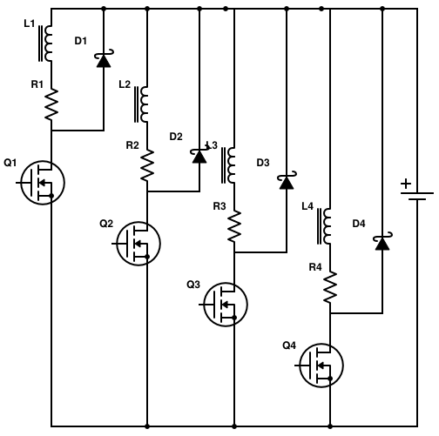

Figure 1 - Linear Motor Schematic

The circuit drawn above shows four solenoids in a parallel circuit connected to a single voltage generator. The solenoids are represented by the combination of a resistor and an inductor; for example, the first solenoid in the circuit can be considered the combination of R1 and L1. The diodes are the arrow like symbols, like the D1 component. The MOSFETs (electrically controllable switches) – Q1, Q2, Q3, and Q4 – are represented by a three-way gate symbol. The solenoids are turned on and off by opening or closing the gates on the MOSFETs attached in the circuit, which are controlled by the microcontroller on the side (not shown). The magnetization of the solenoids exerts a force on the cart, which thus can be propelled down a track. In order to model this system, I created components for the solenoid, the controller, the track, and the cart. Additionally, the magnetization of the solenoids is controlled by the microcontroller using a proximity sensor. This required the creation of a position-sensing component.

## Modeling Approach:

The approach taken to model the linear motor system was to consider the system as a sum of multiple components. The components were abstractions of several parts of the system, where each component contained the information required to describe a specific part of the system. The information describing the system was the physical equations that pertained to overall behavior of the system. These equations ended up being differential equations, and required special solving tools to solve them all. The tool used was Wolfram SystemModeler3, and had symbolic and numerical capabilities for solving ordinary differential equations. The tool itself utilized a powerful language called Modelica, which was developed specifically for modeling physical systems through ordinary differential equations.

## Connections:4

Connections are how the components interact with each other. A connection between components automatically generates equations of equality between components. There are two types of connectors: acausal, and causal. The types of equations being generated depend on the types of connectors used. If it is a causal connector, the equation generated will be a simple equation of equality, representable as

$$Input=Output$$

The direction of the flow of information is dependent connector setup – an input can be connected to an output, but not vice versa.

If the connectors are acausal connectors, then the connections would produce two types of equations, due to the type of information being passed through the connectors. Acausal connectors have both a flow and across variable. The flow and across variables can be considered to be as follows: the across variable represents a type of potential, and the flow variable represents the flow of a quantity from one object to another, caused by a change in the across variable. When acausal connectors are connected, the two equations produced are the equality equations and the conservation equations. Let $a$ represent the across variable, and $b$ the flow variable. The equations generated are as follows

$$a_{connector 1}=a_{connector 2}$$

$$b_{connector 1}+b_{connector 2}=0$$

In my model, I used both causal and acausal connectors, but the major connections were all acausal. This is because the most important connections were those between components. Between components, the information that needed to be communicated was about the position and force. For the across variable, position was used, and for the flow variable, force was used. This was because with a small change in the position, the solenoid force would change, and thus this would cause a change in the flow across connections. When using force as a flow variable, it is important to consider the actual ‘flow’ of force across components. For example, the force between a solenoid and the cart can be considered to flow *from* the solenoid *to* the cart. This means that the force that is pulling on the cart is the exact negative of the force exerted on the solenoid in return (this can be easily confirmed by Newton’s Third Law).

## Components:

The importance of components is that it allows localization of the differential equations that represent the system. For example, when considering the differential equations involving the cart, the equations representing the cart’s motion can be collected into one component, allowing for easier construction of larger models requiring more than one cart by simply instantiating the component as many times as necessary. This is useful in order to isolate the interactions between different parts of the system to just the basic connections between the components.

## Solenoid:5

A solenoid is simply an electromagnet, created by wrapping wire into the form of a coil around a solid paramagnetic core. The solenoid component’s purpose is to represent the important equations describing the solenoid’s behavior. The following is the derivation of the equations describing the current going through a solenoid, as well as the force exerted by the solenoid on the cart.

**Derivation of Solenoid-related formulas**

**Basic Definitions**

The magnetic flux $ϕ$ is related to the magnetic field $B$ and the cross sectional area $A$ by the following equation:

$$ϕ=\int{B dA}$$

When $B$ is constant with respect to $A$, we can write this as

$$ϕ=BA$$

The current running through an electromagnet $I$ and the number of coils on an electromagnet $N$ can be represented, with $H$ representing the magnetic moment, by the following equation

$$NI=\int{Hdx}$$

When the magnetic moment is constant over distinct lengths of a medium $x_{medium}$, we represent this as

$$NI=\sum{H_{medium}∙x_{medium}}$$

The power running through a circuit of voltage $V$ and current $I$ is given by

$$P=VI$$

When a current $I$ is passed through an inductor with $N$ coils, such as in the following circuit,

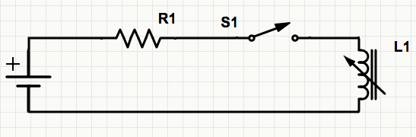

Figure 2 - Simple Inductor Circuit

there is a back electromotive voltage present given by

$$ε=-N\frac{dϕ}{dt}$$

From Kirchoff’s Law, we have

$$\sum_{k=1}^{n}{V_{k}}=0$$

Therefore we have, from evaluating the summation $V-IR+ε=0$ which can be rewritten as

$$V-IR=N\frac{dϕ}{dt}$$

**Determining the magnetic flux $ϕ$ in a circuit**

Consider a magnetic circuit consisting of one part where the magnetic flux goes through an iron core of an electromagnet of $N$ coils and a current $I$ passing through, and a second part where the magnetic flux goes through the air. Assuming that $H_{CORE}$ is constant throughout iron core, and that $H_{AIR}$ is constant in the air, we can write that

$$NI=H_{AIR}x_{AIR}+H_{CORE}x_{CORE}-(1)$$

Now, we make our second assumption6, i.e. will vary linearly with the magnetic flux density $B$ in the following fashion

$$H_{n}=\frac{B_{n}}{μ_{n}}$$

$μ$, the magnetic permeability of the medium through which the magnetic field travels through, will vary depending upon the properties of the substance. Substituting this relationship into equation (1), we get

$$NI=\frac{B_{AIR}}{μ_{AIR}}x_{AIR}+\frac{B_{CORE}}{μ_{CORE}}x_{CORE}$$

But now, as we have considered $H_{n}$ to be constant throughout each individual substance, we can say that $B_{n}$ will be constant throughout each substance. As the magnetic flux $ϕ$ will remain the same throughout the entire magnetic circuit, we can say that for each part of the circuit, through the core and the air, $A$ will also remain constant, allowing us to make the substitution $B=\frac{ϕ}{A}$ in the equation, giving us

$$NI=\frac{ϕ}{A_{AIR}μ_{AIR}}x_{AIR}+\frac{ϕ}{A_{CORE}μ_{CORE}}x_{CORE}$$

Factoring out $ϕ$ and $μ_{AIR}$, we get

$$NI=\frac{ϕ}{μ_{AIR}}\left(\frac{x_{AIR}}{A_{AIR}}+\frac{x_{CORE}}{A_{CORE}}\frac{μ_{AIR}}{μ_{CORE}}\right)$$

­The ratio of $\frac{μ_{AIR}}{μ_{CORE}}$ is very close to $0$, since the difference in the magnetic permeability between the iron core and the air is on the order of ${10}^{7}$. This leaves us with

$$NI=\frac{ϕx_{AIR}}{μ_{AIR}A_{AIR}}$$

We can rewrite this as

$$ϕ=\frac{NIμ_{AIR}A_{AIR}}{x_{AIR}}$$

**Determining the current flowing through the circuit**

We now use this relation in Kirchoff’s Law (for simplicity the subscripts have been omitted:

$$V-IR=N\frac{dϕ}{dt}$$

$$V-IR=N\frac{d}{dt}\left[\frac{NIμA}{x}\right]$$

Ordinarily, the position does not change with respect to time, and thus we get the formula

$$V-IR=\frac{N^{2}IμA}{x}\frac{dI}{dt}$$

However, since in this linear motor system, the position is changing with respect to time, we evaluate the derivative to determine the effect change in time will have on the potential drop across the circuit

$$V-IR=N^{2}μA\frac{d}{dt}\left[Ix^{-1}\right]$$

From the Product Differentiating Rule, we get that

$$V-IR=N^{2}μA\left[\frac{1}{x}\frac{dI}{dt}-\frac{I}{x^{2}}\frac{dx}{dt}\right]$$

We can rewrite this, with $v$ being the velocity, or $\frac{dx}{dt}$, to give us the differential equation determining the current in the circuit:

$$V-IR=N^{2}μA\left[\frac{1}{x}\frac{dI}{dt}-\frac{v∙I}{x^{2}}\right]$$

**Determining the magnetic force exerted by the solenoid**

Let us start by considering the equation for power in a circuit,

$$P=VI$$

The work done by the power is

$$W=\int{VI dt}$$

The $V$ in question here is the emf present across the electromagnet. The $ϕ$ can be determined from the equation for $ϕ$

$$I=-\frac{ϕx}{NμA}$$

Thus, we get the equation for work to become

$$W=\int{N\frac{dϕ}{dt}\left(-\frac{ϕx}{NμA} \right)dt}$$

which can be simplified as follows:

$$W=-\frac{x}{μA}\int{ϕ dϕ}$$

$$W=-\frac{x}{μA}\left[\frac{1}{2}ϕ^{2}\right]$$

$$W=-\frac{ϕ}{2}\frac{x}{μA}\left(\frac{NIμA}{x}\right)$$

$$W=-\frac{1}{2}NϕI$$

The stored potential energy we can determine from

$$W=-U$$

giving us

$$U=\frac{1}{2}NϕI$$

Potential energy is related to force as

$$F=-\frac{dU}{dx}$$

Using this to determine the force, we have

$$F=-\frac{d}{dx}\left[\frac{1}{2}NϕI\right]$$

This we can evaluate to get the following

$$F=-\frac{d}{dx}\left[\frac{1}{2}NI\frac{NIμA}{x}\right]$$

$$F=-\frac{N^{2}I^{2}μA}{2}\frac{d}{dx}\left[\frac{1}{x}\right]$$

This results in the equation for the force exerted by the solenoid:

$$F=\frac{N^{2}I^{2}μA}{2x^{2}}$$

**In summary, the two main equations used in the construction of the model are:**

$$V-IR=N^{2}μA\left[\frac{1}{x}\frac{dI}{dt}-\frac{v∙I}{x^{2}}\right]$$

$$F=\frac{N^{2}I^{2}μA}{2x^{2}}$$

## Simple Dynamic Model Components

The initial iteration of the modeling process used one-dimensional mechanics to model the system. This was done using custom-built components to conduct a quick, albeit rudimental, analysis of the system. In this system, the components defined were one for the mass, the track, and controls. Below is the diagram representation of the entire system.

Figure 3 - Simple Dynamic Model - Diagram View

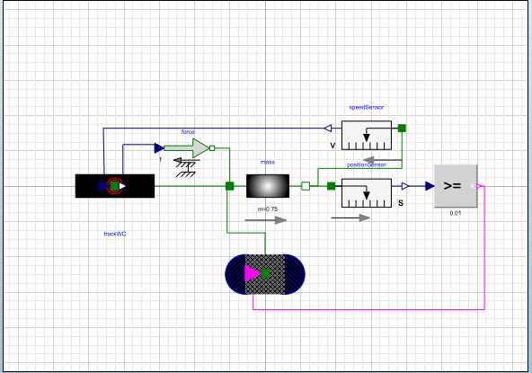

Sensing components

Mass component

Track component

Solenoid component

Controls/Logic component

## Cart:

The cart was modeled in the linear dynamics iteration as a simple mass that moves when under the influence of an external force applied at the flanges. The air drag is considered to be negligible. As the cart is only moving in one direction, the sum of torques acting upon the cart is taken to be 0, and is not considered in the calculations. The equation describing the cart is thus

$$\sum{F}=m\frac{d^{2}x}{dt^{2}}$$

## Track:

The track is a representation of the constant forces acting upon the mass. This includes friction and gravity. Assuming that the wheels on the cart roll without slipping, we can represent the friction simply as

$$F_{friction}=-μ_{s}N_{normal}$$

with N as the normal force acting on the cart, and the effective gravity acting in the plane of the incline as

$$F_{g}=mg\sin{θ}$$

Frictional force varies in direction depending on the velocity however, and thus it would be necessary to incorporate the difference caused by the velocity. Doing a sudden switch when the cart comes to rest would result in the solver being unable to determine what to do when the velocity becomes zero, due to the discontinuity. In order to avoid that, I had the frictional force be defined by a linear function when the velocity became smaller than a certain tolerance level, with endpoints of the linear segment the possible values for the frictional force. This was written as

When velocity is positive, and the speed is greater than the tolerance level $f_{tol}$

$$F_{friction}={-μ}_{s}N$$

When velocity is negative, and the speed is greater than the tolerance level $f_{tol}$

$$F_{friction}=μ_{s}N$$

When the speed is smaller than tolerance level $f_{tol}$

$$F_{friction}=\frac{{-μ}_{s}N}{f_{tol}}v$$

## Control:

The control in the system is the collection of both sensors and logic operations. The control idea was initially to magnetize pairs of solenoids at a time, by using preset timings to open and close the gates appropriately. However, I decided to go with a position-sensing based approach, as that would add more sophistication in the model, since realistically a hard coded approach to the control logic would not work. Thus, I ended up forming the control by using a position sensor, and comparative logic. The logic was a comparison between the position measured by the sensor, and a threshold parameter value. If the position recorded indicated the cart had come within a certain threshold distance between the solenoid and the cart, then the MOSFET gate would be opened.

## Three Dimensional Multi Body Dynamics:

In order to improve the behavior of the model of the linear motor system, a second iteration was done. Compared to the first version, which was a one-dimensional representation of the system, the second iteration was done considering all three dimensions. The Modelica.Mechanics.MultiBody7 library was utilized for most of the components creating the system. In the second iteration, the only specialized virtual component utilized was the component for the solenoid. One of the major benefits obtained from using the standardized components from the library was that it solved the scalability problem experienced in the simple model. Since the simple model was constructed out of customized models, it was difficult to add more complexity to the model, such as more solenoids, and more carts. With the new model, it became much easier to scale up the number of solenoids, carts, and other components in the model. Additionally, the new model could avoid the problems that arose in the first model concerning gravity. Because gravity is defined in the world inertial frame, the initial model, which used a one-dimensional view on the interaction between forces, could not properly construct the idea of gravity. Thus, the model had to resort to using a specialized case of gravity, which would not hold true if the construction of the system changed. However, with the new model, as it included the three-dimensional worldview, it could define gravity in the inertial world frame and the solenoid forces along the frame of the track. This, and other such instances of corrected property definitions, led to a more accurate model when using the multi-body dynamic library.

The greatest advantage gained by using the MultiBody library was that the model became able to generate animations of the system as a whole. This visualization of what happens in the system is extremely powerful towards both enabling understanding of the system as well as debugging problems encountered through parameter changes. Below is a picture of an animation generated through the model.

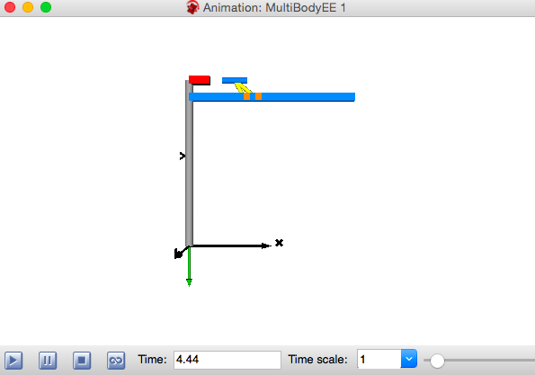

World Frame

Track

Solenoids

Force Representation (Yellow)

Cart

Displacement

Figure 4 - Three Dimensional Graphic Animation of the MultiBody model

## Results:

Below are multiple graphs generated by varying the frictional parameter d (damping coefficient) in the MultiBody model:

Graph 1 - Position vs. Time for different values of 'd'

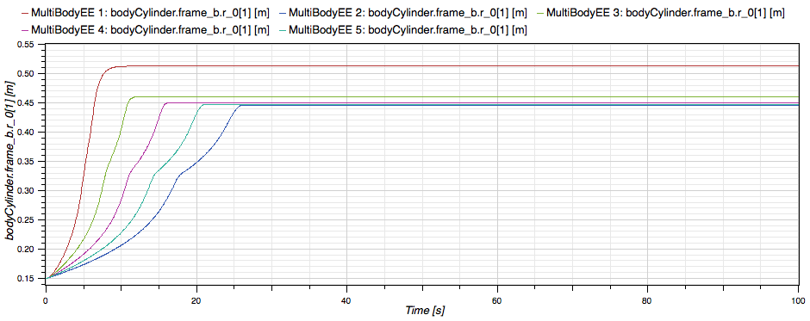

d = 0.1

d = 0.2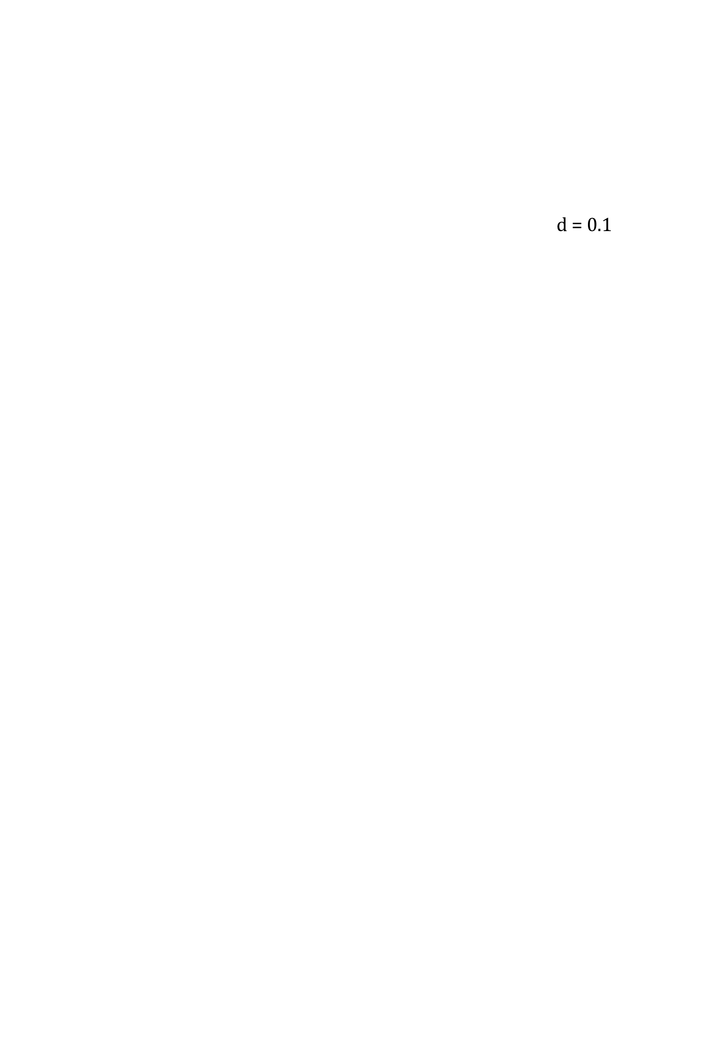

d = 0.3

d = 0.4

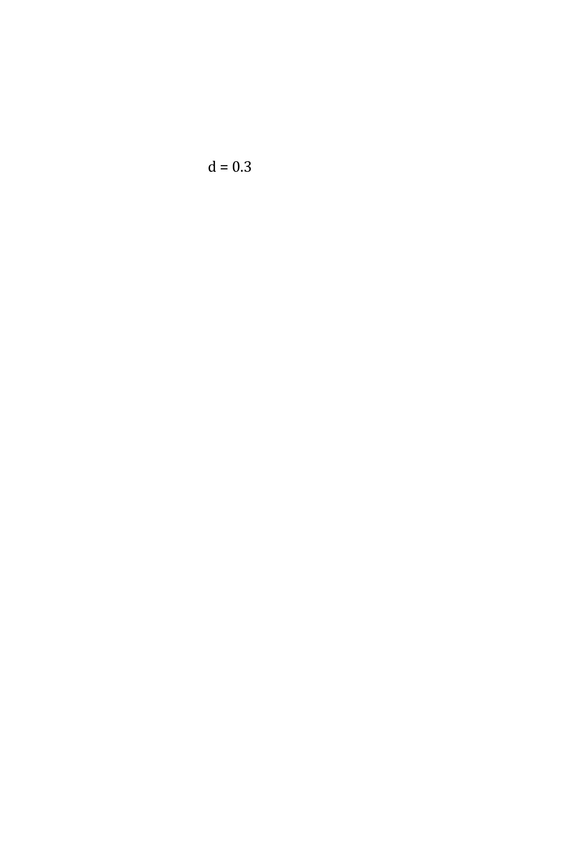

d = 0.5



The results from the multiple parameter changes indicate that the model is able to predict the motion of the cart when the design parameter changes. This is evidenced, for example, with the frictional parameter change. It shows that not only does the total position moved by the cart increase with lower damping, but also the change in total position is nonlinear with respect to the change in the damping coefficient value. Furthermore, it can also be noticed that there is a significant drop in the velocity between solenoids at higher damping ratios, which is seen as a pause in the motion.

Below are another set of results generated by varying the voltage V supplied to the solenoid:

Graph 2 - Position vs. Time for different values of 'V'

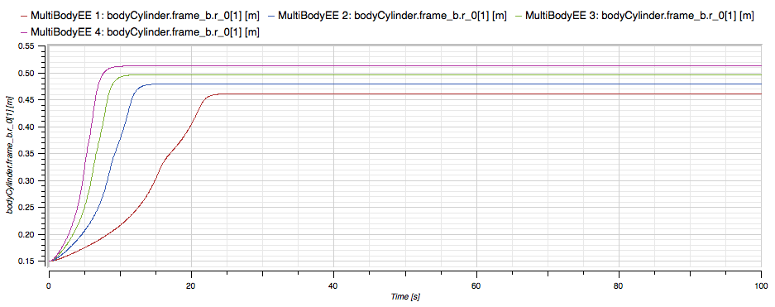

V=20

V=15

V=10

V=5

The second experiment considers how the change in the voltage supplied to the solenoid would effect the position traveled by the cart. First, it can be noted that the total distance travelled by the cart increases with an increase in the voltage. Again, similar to previous experiment, this increase is nonlinear. The implication of this is that since there is little difference between when V = 20 and V = 10, one does not have to use a voltage source of the highest capability in order to ensure reasonable performance.

## Conclusion:

The results, as shown above, demonstrate that computer modeling of the linear motor system by using physical equations provides a reasonable representation of the linear motor system. This makes it possible to use the model for eventual optimization of the output performance. There were two different models created to represent the system. The first model created was built from customized virtual components, which provided a quick way of analyzing the system. However, this provided only a rudimentary glance, and thus the second model was created, using a three-dimensional multi-body dynamic library in order to address the problems with the first model. Because the second model used standardized components, it had the ability to generate animations of the system being modeled, and thus could provide visualizations, which made understanding the effects of changes in the system much easier. The animations proved to be a powerful representation of the system that was far better than even the numerical predictions determined by the solutions of the differential equations describing the system. This special capability of the second model lends itself to the further systematic investigation of the system, such as the optimization of various aspects of the linear motor design. Thus, in conclusion, it is possible to represent the solenoid-based linear motor design through computer modeling, by using equations to represent different parts of the system. Furthermore, the model that is created can be used for the optimization of the performance of the system, with the use of powerful visualizing capabilities.

## Citations:

*1 Vehicle platooning and automated highways* [Fact sheet]. (n.d.). Retrieved February 10, 2015, from <http://www.path.berkeley.edu/PATH/Publications/Media/FactSheet/VPlatooning.pdf>

2 Johnson, Andrew P., and Massachusetts Institute of Technology. Dept. of Electrical Engineering and Computer Science. "High Speed Linear Induction Motor Efficiency Optimization." DSpace@MIT:. Massachusetts Institute of Technology, 2005. Web. 05 Mar. 2015. <http://dspace.mit.edu/handle/1721.1/33562>.

3 "Wolfram SystemModeler." : High-Fidelity Systems Modeling Environment—Insight, Innovation, and Results. Wolfram, n.d. Web. 05 Mar. 2015. <http://www.wolfram.com/system-modeler/>.

4 Tiller, Michael. "Modelica by Example." Modelica by Example. KickStarter Project, 10 Mar. 2014. Web. 05 Mar. 2015.

5 Halliday, David, Robert Resnick, and Jearl Walker. Fundamentals of Physics. New York: Wiley, 2001. Print.

6 Vogel, O., and J. Ulm. Theory of Proportional Solenoids and Magnetic Force Calculation Using COMSOL Multiphysics (n.d.): n. pag. 2011 Comsol Conference in Stuttgart. Comsol. Web. 29 Feb. 2015. <http://www.comsol.jp/paper/download/83443/vogel_paper.pdf>.

7 "Modelica.Mechanics.MultiBody." Modelica.Mechanics.MultiBody. Maplesoft, n.d. Web. 05 Mar. 2015. <http://www.maplesoft.com/documentation_center/online_manuals/modelica/Modelica_Mechanics_MultiBody.html#Modelica.Mechanics.MultiBody>.